SESSION 13
TASK 1:
use mybd;
Select * from Orders;
CREATE TABLE Orders
(order_id INT PRIMARY KEY,
user_id INT NOT NULL,
order_amount DECIMAL(10, 2) NOT NULL,
app_name VARCHAR(50) NOT NULL
);

-- 2. Insert sample dataset (10 records)
INSERT INTO Orders (order_id, user_id, order_amount, app_name) VALUES
(101, 1, 450.00, 'Zomato'),
(102, 2, 1200.50, 'Flipkart'),
(103, 1, 280.00, 'Swiggy'),
(104, 3, 3500.00, 'Flipkart'),
(105, 4, 150.00, 'Zomato'),
(106, 2, 620.00, 'Swiggy'),
(107, 5, 890.00, 'Zomato'),
(108, 3, 210.00, 'Swiggy'),
(109, 6, 4500.00, 'Flipkart'),
(110, 4, 310.00, 'Zomato');

Select * from Orders;
use mydb;

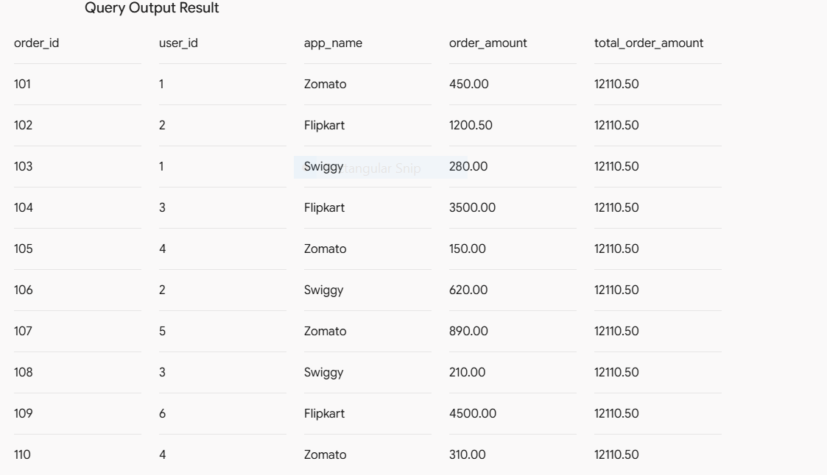

TASK 2:
use mydb;
select * from Ord;
CREATE TABLE Ord (
order_id INT PRIMARY KEY,
user_id INT NOT NULL,
order_amount DECIMAL(10, 2) NOT NULL
);

-- Insert sample data
INSERT INTO Ord (order_id, user_id, order_amount) VALUES
(101, 1, 100.00),
(102, 1, 200.00),
(103, 2, 50.00),
(104, 2, 150.00),
(105, 2, 100.00),
(106, 3, 300.00);

Select
order_id,
user_id,
order_amount,
AVG(order_amount) OVER (PARTITION BY user_id) AS avg_user_order_amount
FROM
Ord;
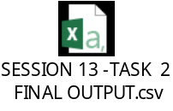
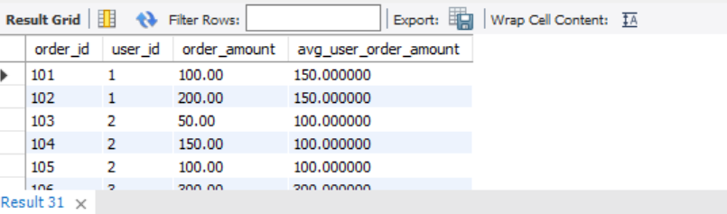

TASK 3:
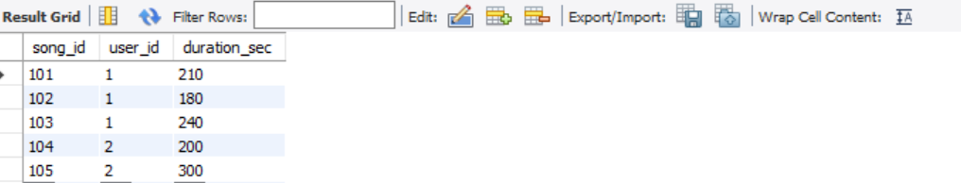

use mydb;
select * from Musiclists;
CREATE TABLE Musiclists (
song_id INT PRIMARY KEY,
user_id INT NOT NULL,
duration_sec INT NOT NULL
);
-- Insert sample records
INSERT INTO Musiclists (song_id, user_id, duration_sec)
VALUES
(101, 1, 210),
(102, 1, 180),
(103, 1, 240),
(104, 2, 200),
(105, 2, 300);
SELECT
song_id,
user_id,
duration_sec,
SUM(duration_sec) OVER (PARTITION BY user_id) AS total_user_duration_sec

FROM
musiclists;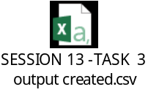

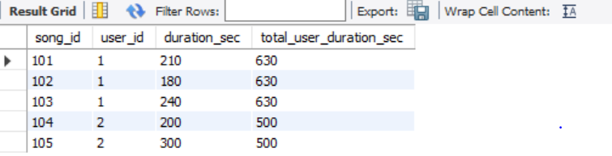

TASK 4:
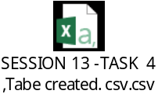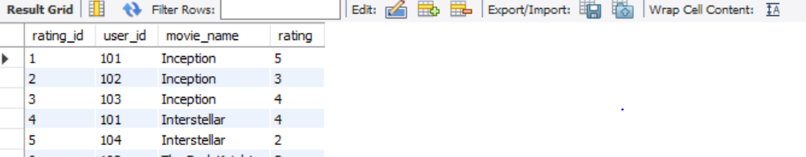
use mydb;
Select * from Movieratings;
CREATE TABLE MovieRatings (
rating_id INT PRIMARY KEY,
user_id INT NOT NULL,
movie_name VARCHAR(255) NOT NULL,
rating INT CHECK (rating BETWEEN 1 AND 5)
);

-- Insert sample data
INSERT INTO MovieRatings (rating_id, user_id, movie_name, rating) VALUES
(1, 101, 'Inception', 5),
(2, 102, 'Inception', 3),
(3, 103, 'Inception', 4),
(4, 101, 'Interstellar', 4),
(5, 104, 'Interstellar', 2),
(6, 102, 'The Dark Knight', 5),
(7, 103, 'The Dark Knight', 5);
Select * from Movieratings;

Select
rating_id,user_id, movie_name,rating,
Avg(rating)Over(partition by movie_name) as Avg_movie_rating,
rating - AVG(rating) OVER(PARTITION BY movie_name) AS rating_difference
FROM
MovieRatings;
